## **Lab_Day-1 ANP-C9180 (Introduction to Python)**

**Q1. Windows Installation**

**Using the Python Installer:**

* **Download Python 3.12.4**:
  + Visit the official Python downloads page: [Python 3.12.4 download](https://www.python.org/downloads/release/python-3124/)
  + Choose the Windows installer (either 64-bit or 32-bit, depending on your system).

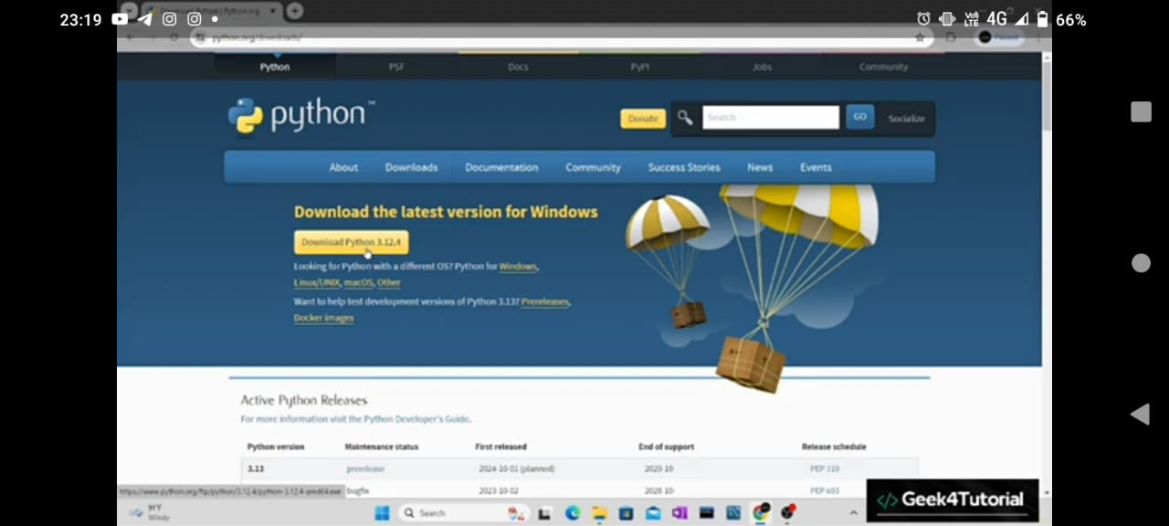

**2. Run the Installer**:

* Once the installer is downloaded, double-click on it to begin the installation.
* In the installer window:
  + **Important**: Check the box that says "Add Python to PATH" (this makes Python accessible from the command line).
  + Click on "Customize installation" to customize the installation settings, or just click on "Install Now" for the default installation.

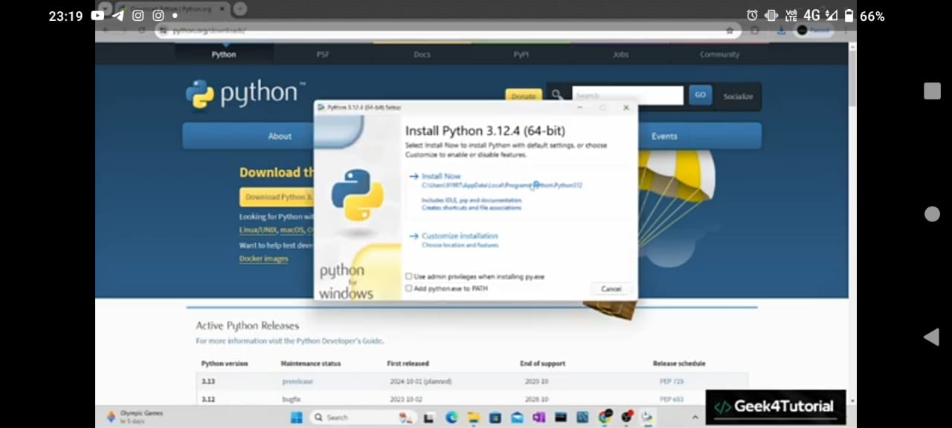

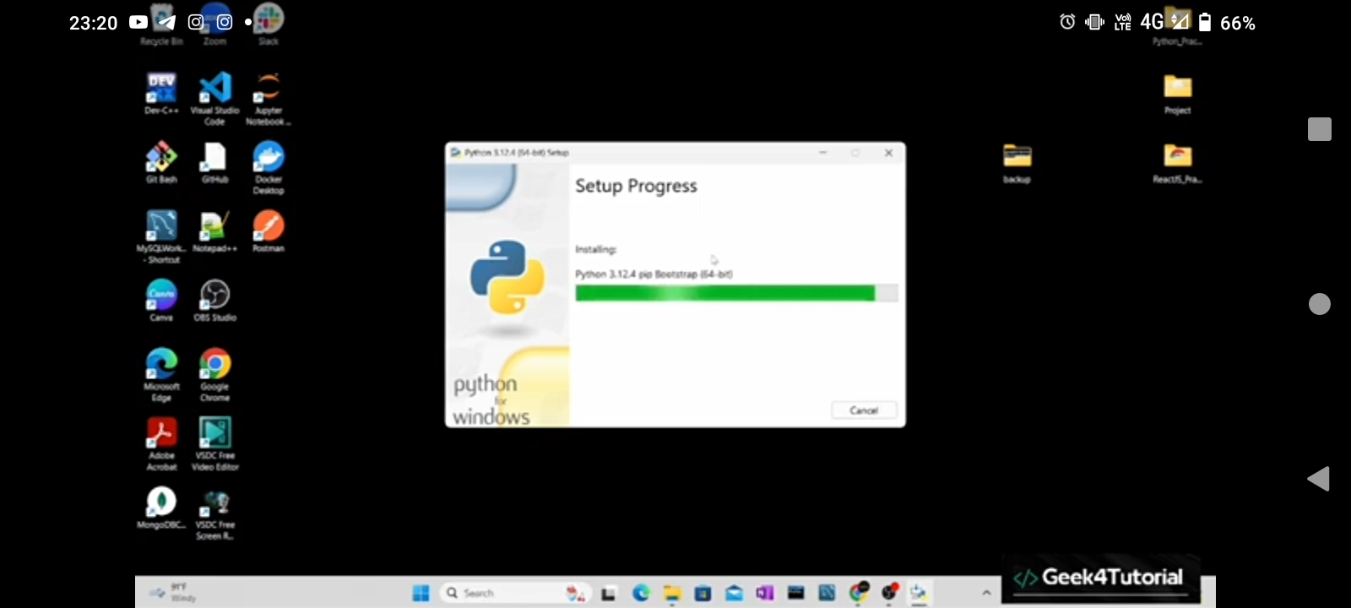

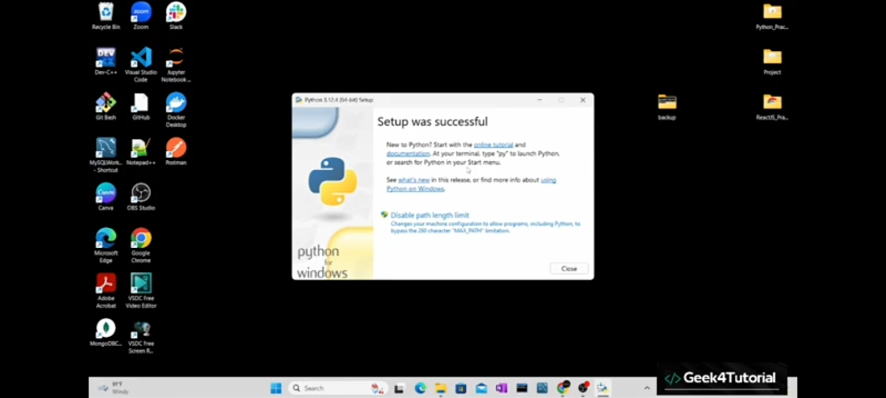

**Q2. Demonstrate about Basics of Python Programming:**

i. **Running Python Interpreter**

ii. **Running Python Scripts in IDLE (Integrated Development and Learning Environment)\**

iii. **Indentation in Python**

**3. Verify the Installation**:

* After installation, open **Command Prompt** and type:

Copy code

python --version

This should display Python 3.12.4.

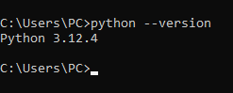

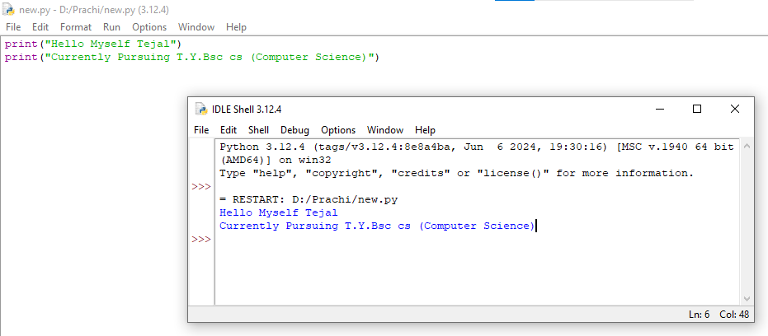

* Python relies on **indentation** (spaces or tabs) to define the structure of the code. Unlike other programming languages that use curly braces {} to mark blocks of code, Python uses indentation to indicate which statements belong to a certain block (like a function, loop, or condition).

